**Experiment No: 10**

Develop a webpage for creating session and persistent cookies. Observe the effects with Browser cookie settings.

**Resources required:**

|  |  |
| --- | --- |
| **Hardware** | **Software** |
| Computer System | 1)Notepad editor  2)Any Web Browser |

**Practical Significance:**

A *cookie* is a small piece of information that a web site writes to your hard disk when you visit the site.

**Theoretical Background**

A JavaScript can be used to create cookies whenever someone visits the web page that contains the script. A JavaScript can also be used to read cookies stored on a user’s computer, and it uses the information stored in a cookie to personalize the web page that a user visit.

Cookies are usually small text files, given ID tags that are stored on your computer browser directory or program data subfolders.

There are two types of cookies namely: session cookie and persistent cookie.

**1. Session cookie** are created temporarily in your browser’s subfolder while you are visiting a website. Once you leave the site, the session cookie is deleted.

**2.Persistant Cookie** files remain in your browser’s subfolder and are activated again once you visited the website that created that particular cookie.

**10.1 Creating a Cookie:**

The text of a cookie must contain a *name-value pair*, which is a name and value of the information. When you write your JavaScript, you decide on the name and the value.

You cannot include semicolons, commas, or white space in the name or the value unless you precede these characters with the escape character (\). The escape character tells the browser that the semicolon, comma, or white space is part of the name or value and not a special character.

You simply assign the cookie to the window.document.cookie object. The browser automatically writes the cookie to memory when it reads this assignment statement in your JavaScript, unless you set an expiration date for the cookie, which then causes the cookie to be written to the computer’s hard disk.

Every cookie has four parts: a name, an assignment operator, a value, and a semicolon.

The semicolon is a delimiter and not part of the value. A delimiter is a character that indicates where something ends, which in this case is the end of the cookie.

This statement creates a cookie, where CustomerName is the name and ABC is the value:

window.document.cookie = "CustomerName= ABC;"

**Program:**

<html>

<head>

<title>Write Cookie</title>

<script>

function WriteCookie()

{

with (document.CookieWriter)

{

document.cookie =

"CustomerName="+ customer.value+";"

alert("Cookie Written")

}

}

</script>

</head>

<body>

<form name="CookieWriter" action="" >

Enter your name:

<input type="text" name="customer"

onchange="WriteCookie()"/>

</FORM>

</body>

</html>

**10.2 Setting the Expiration Date**

You can extend the life of a cookie beyond the current browser session by setting an expiration date and saving the expiration date within the cookie. The expiration date is typically an increment of the current date.

A date is stored in a variable of a Date data type.

<html>

<head>

<title>Write Cookie with Expiration Date</title>

<script>

function WriteCookie()

{

var expireDate = new Date

expireDate.setMonth(expireDate.getMonth()+3)

with (document.CookieWriter)

{

var CustomerName = customer.value

document.cookie = "CustomerName1="+ CustomerName+";expires="+expireDate.toGMTString()

alert("Cookie Written")

}

}

</script>

</head>

<body>

<form name="CookieWriter" action="" >

Enter your name: <input type="text"

name="customer" onchange="WriteCookie()" />

</FORM>

</body>

</html>

**Exercise:**

1) Write a program to read the cookie.

**Code:**

<html>

  <head>

    <script>

      function writeCookie() {

        with (document.myform) {

          document.cookie = "Name=" + person.value + ";";

          alert("Cookie written");

        }

      }

      function readCookie() {

        var x;

        if (document.cookie == "") x = "";

        else x = document.cookie;

        document.write(x);

      }

    </script>

  </head>

  <body>

    <form name="myform" action="">

      Enter your name:

      <input type="text" name="person" /><br />

      <input

        type="Reset"

        value="Set Cookie"

        type="button"

        onclick="writeCookie()"

      />

      <input

        type="Reset"

        value="Get Cookie"

        type="button"

        onclick="readCookie()"

      />

    </form>

  </body>

</html>

**Output:**

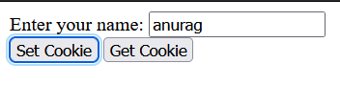

**After clicking on Get Cookie:**

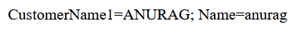

2)Write a program to delete the cookie.

**Answer: To delete a cookie**

You don't have to specify a cookie value when you delete a cookie.

Just set the expires parameter to a past date:

**Code:**

<!DOCTYPE html>

<html>

<head>

    <title>Experiemtn-10</title>

</head>

<body>

    <input type="button" value="Set Cookie1" onclick="setCookie()">

    <input type="button" value="Get Cookie1" onclick="getCookie()">

    <input type="button" value="Delete Cookie1" onclick="deleteCookie()">

    <script>

        function setCookie() {

            document.cookie = "name=Anurag Dubey";

            cookie1 = document.cookie;

            alert("Cookie Written")

        }

        function getCookie() {

            if (cookie1.length != 0) {

                alert(cookie1);

            }

            else {

                alert("Cookie not available");

            }

        }

        function deleteCookie() {

            document.cookie = cookie1 + "; expires=Sun, 20 Aug 2000 12:00:00 UTC";

            cookie1 = document.cookie;

            alert("Cookie is deleted");

        }

    </script>

</body>

</html>

**Output:**

**Set the Cookie:**

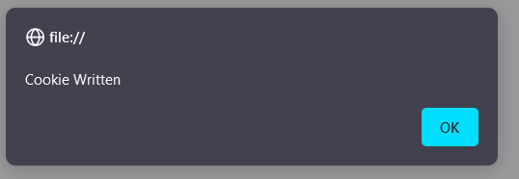

**Get the Cookie:**

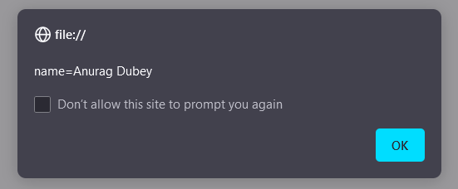

**Delete the Cookie:**

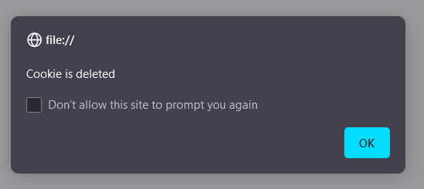

**Get Cookie after Deleting:**

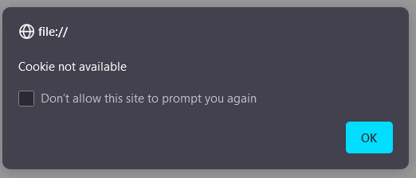

|  |  |  |  |
| --- | --- | --- | --- |
| **Marks Obtained** | | | **Dated Signature of Teacher** |
| **Process Related (15)** | **Product Related**  **(35)** | **Total**  **(50)** |  |
|  |  |  |